Math Foundations 20 Final Exam

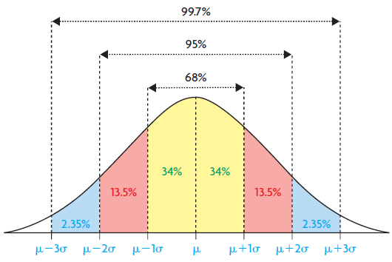
FORMULA SHEET

180∘(n-2) = Sum of the angles

180∘(n-2) = each angle in a regular polygon
n

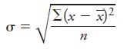 = Standard Deviation
Sin A = Sin B = Sin C
a b c

a² = b² + c² – 2bc cosA
b² = a² + c² – 2ac cosB
c² = a² + b² – 2ab cosC

y = a(x-h)² + k
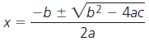
Y = a(x-r)(x-s)
y = ax² + bx +c

